IOTC Assignment Report
Suresh Kumar
25MSDFR031

Introduction
The objective of the assignment was to create a practical Internet of Things (IOT) project that may combine embedded systems, IoT, mobile application development and automation. Also, the idea is expandable with additional features in the future. Accordingly, a smart pet feeder was considered that would dispense feed at regular intervals or through a mobile app command or manually with future extensions like buzzer at feed time, notifications on phone, camera monitoring of device and food level detection.

Project Title
Smart Pet Feeder using IoT with Mobile App Control and Scheduled Feeding.

Aim
To develop an IoT-enabled automatic pet feeder that can:
- Dispense food automatically at scheduled times thereby allowing the owner to feed the pet remotely using a mobile app.
- Support manual feeding using a physical button.
- Keep logs of feeding history.

Architecture of the System
Mobile App

WiFi/Internet

ESP32 Dev Kit

Manual Button
Servo Motor

Opens Feeder

Software/Tools used: Software Stack
Hardware
- ESP32
- Arduino IDE
- C++
IoT
- Firebase Realtime Database (easy for beginners)
- MQTT (more scalable)
App Mobile App development using Flutter.

Android Studio for emulating mobile phone.

Hardware Components

Component | Quantity
ESP32 Development Board | 1
Servo Motor MG996R | 1
5V 2A Power Adapter | 1
Breadboard | 1
Jumper Wires (all types) | 1 pack each
Push Button | 1
LED + Resistor | 2
Buzzer | 1
Food Container | 1
Feeding Bowl | 1
Servo Mount | 1

Development and Working of the Feeder

Phase 1: Development of mobile app.

1. The app was developed using ‘Flutter’.
2. Three pages were developed.
(a) Home page
(b) Schedule page
(c) History page

3. Home Screen

App name – Smart Pet Feeder
Device Status: Online
Food Level: 75% (not incorporated)
Last Fed: 8:00 AM
Next Feed: 2:00 PM
Feed Now – button for manual feed.

Toggle option between the three screens.

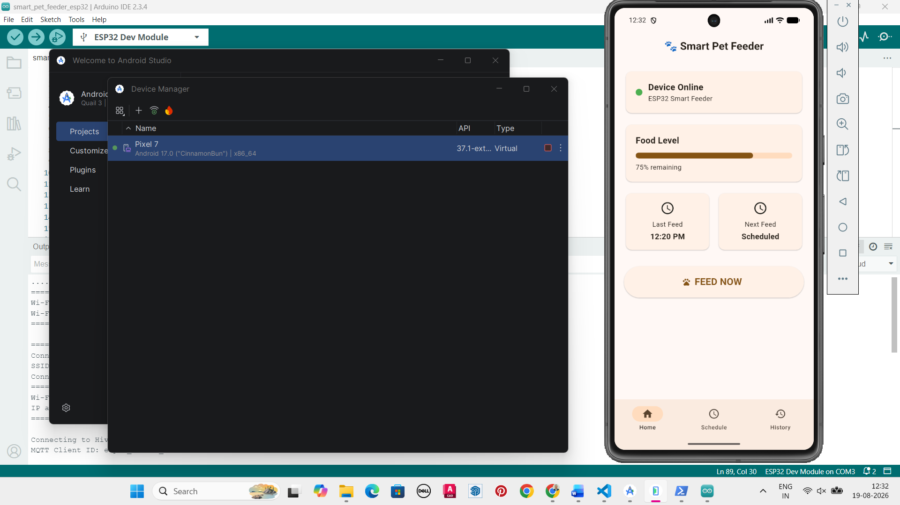

Image 1 – Screenshot of home page of app

4. Schedule page will show the automatic schedule and custom schedule added by owner.

(a) Automatic Schedule
Every day the feeder shall drop feed in the bowl at the following times:
8:00 AM
2:00 PM
8:00 PM
(b) The working principle of the automated schedule is as follows:
- ESP32 checks the time.
- At scheduled time the Servo rotates 90°.
- Food gate opens and food drops into bowl.
- Servo closes.
- Notification sent.
(c) Manual override of automated system
- Owner opens mobile app and Presses ‘Feed Now’ on home page.
- Firebase updates command.
- ESP32 receives command and Servo rotates.
- Food dispenses.
- Command resets.

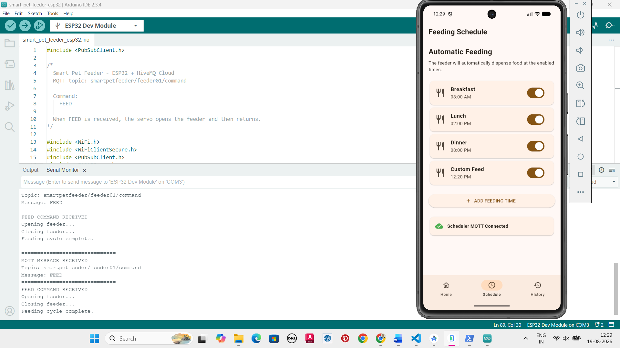

Image 2: Screenshot of schedule page.

5. Feeding History Page. All feeds dispensed alongwith time can be seen on this page.

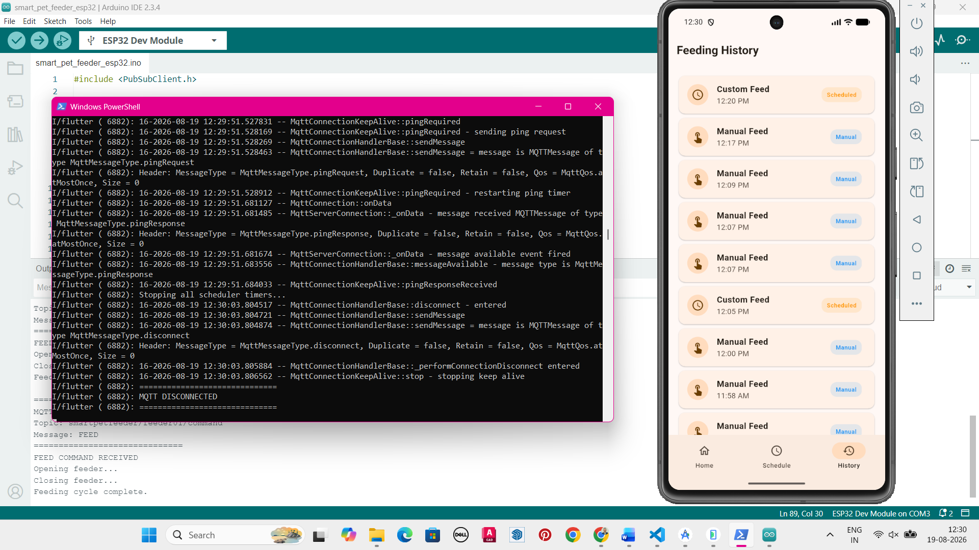

Image 3: Screenshot of History page.

Feeding History
8:00 AM Automatic
2:01 PM Manual
8:00 PM Physical

6. MQTTX setup. A free account was created on HiveMQ and used to send command to device through online app.

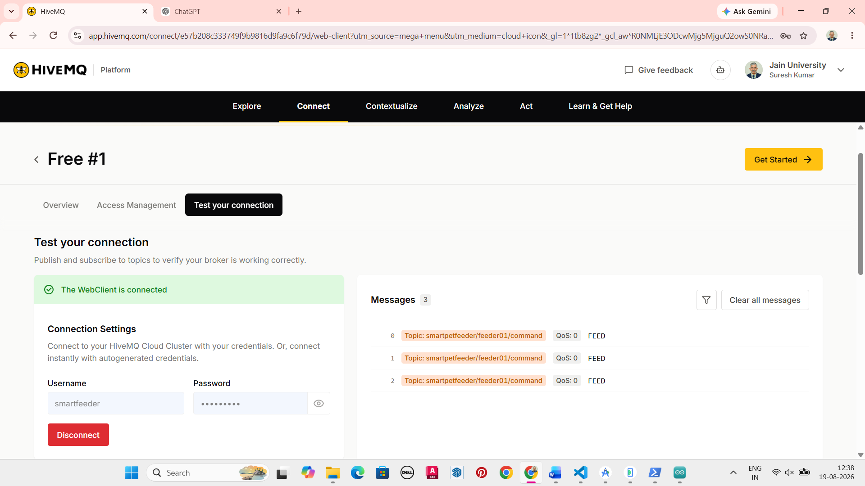

Image 4: Screenshot of HiveMQ depicting

Protocols for communication between App, ESP and hardware.

The protocol architecture of the project is as follows:

Mobile App
https over Internet

MTTX for sending commands from mobile app to ESP32.

Wi-Fi for connecting ESP32 to internet

ESP32 – GPIO for connecting hardware

Servo Motor (MG996R) – independent power and GPIO connections.

Feed Mechanism – mechanical.

Protocols/interfaces involved
Layer / Purpose | Protocol / Interface | Used for
ESP32 ↔ Router | Wi-Fi (802.11) | Wireless Internet connectivity
Mobile App ↔ HiveMQ | HTTPS | Secure communication with cloud
ESP32 ↔ MTTX | MTTX | Sending/receiving feeding commands and status
ESP32 ↔ Servo | GPIO | Controlling MG996R position
App ↔ Cloud | HTTPS or MTTX | Feed Now, schedules, status
Cloud ↔ ESP32 | Realtime synchronization | Delivering commands to feeder

Wi-Fi - The ESP32 connects to your home Wi-Fi. This gives the feeder Internet connectivity.

HTTPS - The mobile application communicates securely with the cloud using HTTPS. This is important because commands such as Feed Now should not be sent as unencrypted HTTP traffic.

MTTX - This acts as the communication layer between the mobile application and ESP32.

GPIO - GPIO is the control signal/interface used by the ESP32 to command the MG996R servo.

The protocol stack may be described as follows:

Application Layer
- MTTX
- HTTPS

Network Layer
- Wi-Fi (802.11)

Device Layer
- GPIO

MQTT (Message Queuing Telemetry Transport) is a lightweight communication protocol designed specifically for IoT devices and the MQTT broker is the middleman which may be used in the enhanced version of the Smart feeder.

Three important MQTT concepts
1. Publisher
The device/application that sends a message.

2. Subscriber
The device that receives/listens for a message.

3. Topic
A topic is like an address where messages are published.

MQTT has the following benefits in this project

- Lightweight — good for ESP32
- Fast — messages are small
- Low bandwidth — doesn't require much data
- Bidirectional — ESP32 can send information back
- Publish/subscribe based — devices don't need to communicate directly
- Suitable for unreliable networks — MQTT has mechanisms for delivery reliability

Final Working model
- Connect all hardware. ESP32 using USB cable and servo motor using independent 5v 2A power supply.
- Open Android studio and virtual device manager. First create a ‘Pixel 7’ mobile and then power it on.
- Open Powershell and cd to the project folder ‘smartpetfeeder’
- Open the mobile app by running ‘flutter run’.
- The app opens on the Pixel 7 emulator.
- Open Arduino IDE 2 and load the ‘.ino’ file. In the serial monitor check and ensure that WiFi connection and MTTX connection are successful.
- Loop
  - Read Schedule
  - Match with Time now
  - If True
    - Rotate Servo
    - Wait 2 seconds
    - Close Servo
    - Update History
- Check ‘Feed Now’ Button.
  - Feed if pressed
  - Update History
- Repeat
Future Enhancements
- Camera to monitor the pet while feeding.
- Voice control with Google Assistant or Alexa.
- Pet identification using RFID tags.
- AI-based feeding recommendations based on pet weight and age.
- Automatic refill alerts.
- Battery backup with charging circuit.
- Cloud analytics showing feeding trends.
- Multi-pet profiles with different feeding schedules.

